Kathi’s Hands
Client Information Form
Name:___________________________________________Date:____________
Address:__________________________________Date of Birth:_____________
_________________________________________________________________
Email address:_____________________________Phone Number:_____________
Preferred Communication Method:_______________________________________ Emergency Contact:________________________Phone Number:_____________
How did you hear about Kathi’s Hands?___________________________________
If applicable, please share their name so they can be thanked…___________________

Have you received professional massage therapy before? ______________________
When was your last session?____________________________________________
What issues are you here today to address?_________________________________ _________________________________________________________________
Please make note on the diagram below, indicating where you are feeling discomfort recently.
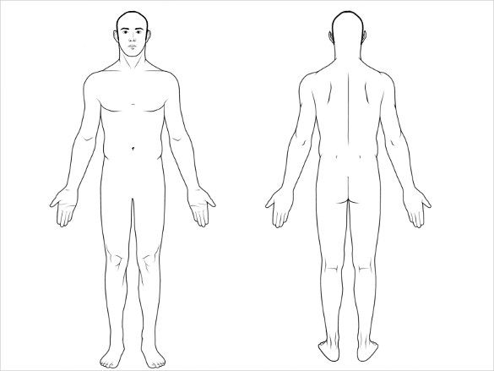
What increases or decreases these issues?_________________________________
What have you done for the issues so far?__________________________________
What surgeries, illnesses or accidents may relate to the issues?___________________
_________________________________________________________________
What goals do you have for today’s treatment?______________________________
_________________________________________________________________
How do you spend most of your time?_____________________________________
Do you exercise? How so and how often?___________________________________
Are you under the care of a prescribing physician?____________________________
If so, for what conditions?________________________________________________
___________________________________________________________________
Are your medications working well?_________________________________________

Consent for Treatment
If I experience any pain or discomfort during this session, I will immediately inform the practitioner so that the pressure and/or strokes may be adjusted to my level of comfort. I further understand that massage/bodywork should not be construed as a substitute for medical examination, diagnosis, or treatment and that I should see a physician, chiropractor, or other qualified medical specialist for any mental or physical ailment of which I am aware. I understand that massage/bodywork practitioners are not qualified to perform spinal or skeletal adjustments, diagnose, prescribe, or treat any physical or mental illness, and that nothing said during the session given should be construed as such. Because massage/bodywork should not be performed under certain medical conditions, I affirm that I have stated all my known medical conditions and answered all questions honestly. I agree to keep the practitioner updated as to any changes in my medical profile and understand that there shall be no liability on the practitioner’s part should I fail to do so. I also understand that any illicit or sexually suggestive remarks or advances made by me will result in immediate termination of the session, and I will be liable for payment of the scheduled appointment. Understanding all of this, I give my consent to receive care.

Missed Appointment Policy
It is understood that some things are not in our control, and that on occasion an appointment must be missed. I agree that one missed appointment will be forgiven each year, and that all others must be reimbursed 100% to keep my future appointments. A missed appointment shall be any that is canceled or rescheduled with less than a week’s notice. Should I be ill on the day of my appointment, I will find someone to take my place or reimburse the appointment after my one freebie. Sick clients will be turned away, and reimbursement will be required after the first missed appointment.

Client Signature: _____________________________________Date: _________

